COMMON COURSE ASSIGNMENT
CSA04 – OPERATING SYSTEMS | Covering Process Scheduling, Memory Management & Disk Scheduling

A. Assignment Information
Department | INFORMATION TECHNOLOGY
Programme | B.E. / B.Tech – IT
Course Code & Course Name | CSA0404 – Operating Systems
Academic Year / Batch | 2026 – 2027
Faculty Name | Dr.Chandravathi
Assignment Title | Design and Implementation of OSLearn – An Interactive OS Algorithm Trainer using Streamlit
Date of Issue | 21/08/2026
Date of Submission | 02/09/2026
Maximum Marks | 100
Course Outcome(s) – CO | CO2, CO3, CO4
Bloom's Taxonomy Level | L3 – Apply, L4 – Analyze, L5 – Evaluate
SDG Mapping (SDG 1–17) | SDG 4 – Quality Education; SDG 9 – Industry, Innovation and Infrastructure
Industry / Societal Relevance | Interactive educational tools improve conceptual understanding of OS algorithms used in real-world servers, cloud platforms, and embedded systems, supporting quality technical education.

B. Assignment Problem / Challenge
This assignment requires students to design, implement, and evaluate an interactive Operating Systems simulator that applies core CSA04 concepts — process scheduling (Units I–II), memory management with paging and page replacement (Unit III), and disk scheduling (Unit IV) — to a unified educational training platform called OSLearn. Students must integrate multiple algorithm families, produce clear comparative visualizations and step-by-step traces, deploy the system as a lightweight web application using Streamlit, validate correctness and usability with sample test cases, and address basic responsible-computing considerations such as transparency of intermediate steps and reproducibility of results.

C. Problem Statement
Scenario: “OSLearn” – Interactive OS Algorithm Trainer
Many students find it difficult to understand how CPU scheduling, page replacement, and disk scheduling algorithms actually work just by reading theory. Your task is to design and implement an interactive educational web application called OSLearn that helps students practice, visualize, and compare these core Operating Systems algorithms through a unified interface.
The system shall integrate three major OS algorithm families:

1. Process Scheduling
Implement FCFS, SJF (Non-preemptive), and Round Robin.
- Users should be able to enter process details (Process ID, Arrival Time, Burst Time, and Time Quantum for Round Robin).
- The system must display a Gantt chart / timeline visualization together with a table showing Waiting Time, Turnaround Time, and Average Waiting/Turnaround Time for each algorithm, enabling side-by-side comparison.

2. Memory Management (Page Replacement)
Implement FIFO and LRU page-replacement algorithms.
- Users will enter the number of frames and a page reference string.
- The system should show the step-by-step frame status after each reference, highlight page faults, and report the total number of page faults for each algorithm so that students can compare performance.

3. Disk Scheduling
Implement FCFS, SSTF, and SCAN.
- Users will enter the disk request queue and the initial head position.
- The system should display the order of servicing (seek sequence) and the total seek time for each algorithm, allowing clear comparative analysis.
Design the application workflow so that user inputs (process lists, reference strings, disk request queues) are processed by the corresponding algorithms and the results are presented as clear tables, Gantt charts, step-by-step traces, and comparative metrics. Develop a clean, simple web interface using Streamlit. Provide 2–3 sample test cases for each module to demonstrate correctness. Optionally, students may add brief natural-language explanations of algorithm steps (no external LLM required).
Evaluate the application under suitable test cases and analyze correctness of algorithm results, usability of the interface, and clarity of visualizations. The completed system should also briefly address responsible-computing considerations including transparency of intermediate simulation steps, reproducibility of results, and educational ethics in presenting algorithm behavior.

D. Requirements and Constraints
- Functional: Provide interactive modules for Process Scheduling (with Gantt charts and timing metrics), Memory Management / Page Replacement (with frame-status traces and page-fault counts), and Disk Scheduling (with seek sequences and total seek times). Accept user inputs as well as sample data. Produce comparative tables, charts, and step-by-step traces.
- Interface: Clean, simple, and user-friendly Streamlit web application with separate pages or clearly separated sections for each module.
- Performance: Simulations must produce correct results with acceptable latency for interactive classroom use and support clear comparative analysis across algorithms.
- Technical constraint: Use Python + Streamlit. No database, no complex architecture, and no mandatory external LLM integration. Open-source tools only.
- Reliability: Algorithm implementations must be correct and reproducible; intermediate steps must be transparent; the system must handle common edge cases without crashing.
- Resource constraint: Project must be completable within the semester timeline using standard student computing resources.
- Responsible Computing: Ensure transparency of simulation steps, reproducibility of results, avoidance of misleading default parameters, and adherence to educational ethics.
- Evaluation & Submission: Test all three modules with sample inputs and show correct results. Submit working Streamlit code, a short report containing sample outputs / screenshots, comparative analysis, and a GitHub repository link.

E. Student Work
1. Problem Understanding and Formulation
1.1 Understanding of the Problem
Campus Connect is considered as a shared digital academic environment in which hundreds of users may simultaneously access academic files, upload documents, stream videos, and perform other file-related operations. Such an environment places significant demands on the Operating System because multiple processes compete for CPU time, memory frames, files, disk resources, and synchronization objects.
The major challenge is therefore not simply storing or accessing data, but managing shared resources efficiently, fairly, and safely under concurrent workloads.
The proposed design focuses on three interconnected OS layers:
- Process Synchronization and Deadlock Management – prevents race conditions and unsafe resource allocation.
- Memory Management – uses paging and page-replacement techniques to minimize unnecessary page faults and prevent thrashing.
- File Systems and Disk Scheduling – provides efficient storage allocation and fair disk access.
The overall objective is to create a resource-management design that provides:
Safety + Efficiency + Fairness + Reliability

1.2 Challenges Identified
Area | Challenge
Synchronization | Multiple users may read/write the same academic file simultaneously
Race Conditions | Concurrent updates may produce inconsistent file contents
Deadlock | Processes may wait indefinitely for resources held by one another
Memory | Hundreds of concurrent sessions increase memory pressure
Page Replacement | Poor replacement decisions increase page faults
Thrashing | Excessive paging can reduce CPU utilization
File Allocation | Workload ranges from small documents to multi-GB videos
Disk Scheduling | Large numbers of I/O requests may increase waiting time
Fairness | One user or process should not monopolize shared resources

1.3 Expected Outcomes

The proposed system aims to achieve:

- Deadlock-free or controlled resource allocation.
- Race-condition-free access to shared academic files.
- Efficient utilization of physical memory.
- Reduced page-fault frequency.
- Prevention of excessive thrashing during peak usage.
- Efficient storage of files with different sizes.
- Reduced disk-head movement.
- Fair access to shared resources.
- Reproducible and transparent algorithmic results.

1.4 Assumptions

For the purpose of simulation and analysis, the following assumptions are made:

- Number of concurrent sessions: 300
- Physical memory: 8 GB
- Page size: 4 KB
- Representative process logical address space: 64 MB
- Number of page frames used for page-replacement simulation: 3
- Disk size: 200 cylinders (0–199)
- Disk scheduling direction: towards higher-numbered cylinders initially
- Resource types: database handle, print spooler, network socket, and file lock.
- The page reference string and disk request queue are representative workloads constructed for evaluation.
These assumptions provide a manageable but realistic environment for demonstrating OS resource-management concepts.

2. Application of Course Knowledge

Part I – Process Synchronization and Deadlock

2.1 Shared-File Access as a Readers-Writers Problem
The Campus Connect file-access problem can be model using the Readers-Writers synchronization problem.
Multiple users may read an academic file simultaneously because reading does not modify the file. However, writing must be exclusive because a writer modifying the file while another writer or reader is accessing it can lead to inconsistent or corrupted data.
The following semaphore-based design gives priority to writers and prevents race conditions.
Semaphores and Variables
- rw_mutex = 1 → controls access to the shared file.
- mutex = 1 → protects the reader counter.
- read_count = 0 → number of active readers.
Reader Pseudocode
READER()
wait(mutex)
read_count = read_count + 1
if read_count == 1:
wait(rw_mutex)
signal(mutex)
READ_SHARED_FILE()
wait(mutex)
read_count = read_count - 1
if read_count == 0:
signal(rw_mutex)
signal(mutex)
Writer Pseudocode

WRITER()
wait(rw_mutex)
WRITE_SHARED_FILE()
signal(rw_mutex)

Explanation

The first reader locks the shared file against writers. Additional readers can enter simultaneously. When the last reader leaves, the writer lock is released.
A writer must obtain rw_mutex, meaning that no other writer or reader can access the file during the write operation.
Thus:
Multiple Readers → Allowed
Reader + Writer → Not Allowed
Multiple Writers → Not Allowed
This eliminates race conditions and protects the integrity of shared academic files.

2.2 Banker's Algorithm

Four resource types are considered:
- R1: Database Handle
- R2: Print Spooler
- R3: Network Socket
- R4: File Lock
The following example allocation and maximum matrices are constructed for analysis.

Allocation Matrix

Process | DB Handle | Printer | Socket | File Lock
P1 | 1 | 0 | 1 | 0
P2 | 1 | 1 | 0 | 1
P3 | 1 | 0 | 1 | 1
P4 | 0 | 1 | 0 | 0

Maximum Matrix
Process | DB Handle | Printer | Socket | File Lock
P1 | 2 | 1 | 1 | 1
P2 | 1 | 2 | 1 | 1
P3 | 2 | 1 | 2 | 1
P4 | 1 | 1 | 1 | 1

Available Resources

Available = [1, 1, 1, 1]
Need Matrix
The Need matrix is calculated as:
Need = Maximum − Allocation
Process | DB Handle | Printer | Socket | File Lock
P1 | 1 | 1 | 0 | 1
P2 | 0 | 1 | 1 | 0
P3 | 1 | 1 | 1 | 0
P4 | 1 | 0 | 1 | 1

Safety Algorithm
Initial:
Work = [1,1,1,1]

Step 1 – Check P1

Need(P1) = [1,1,0,1]
Since:
[1,1,0,1] ≤ [1,1,1,1]
P1 can finish.
After P1 releases its allocation:
Work = [2,1,2,1]

Step 2 – Check P2

Need(P2) = [0,1,1,0]
P2 can finish.
Work = [3,2,2,2]

Step 3 – Check P3

Need(P3) = [1,1,1,0]
P3 can finish.
Work = [4,2,3,3]

Step 4 – Check P4

Need(P4) = [1,0,1,1]
P4 can finish.
Therefore, a safe sequence is:
P1 → P2 → P3 → P4
Result
Since every process can complete successfully, the system is in a:
SAFE STATE
The Banker's Algorithm therefore confirms that the selected resource allocation does not lead to a deadlock under the given assumptions.

2.3 Recommended Deadlock-Handling Strategy
For Campus Connect, Deadlock Avoidance is the most appropriate primary strategy.
Justification
The environment contains valuable shared resources such as file locks, database handles, network resources, and printing services. Allowing the system to enter an unsafe state and recovering afterward could cause service interruption and potentially affect academic data.
Deadlock prevention can impose rigid restrictions on resource usage, while detection and recovery may discover the problem only after it occurs.
Banker's Algorithm provides a more controlled approach by allowing resource requests only when the resulting state remains safe.
Therefore:
Recommended Strategy = Deadlock Avoidance using Safe-State Analysis
A practical system can combine this with timeouts and resource monitoring as secondary safeguards.

3. Memory Management

3.1 Number of Physical Frames
Given:
Physical Memory = 8 GB
Page Size = 4 KB
Using:
1 GB = 1024 × 1024 KB
Therefore:
8 GB = 8 × 1024 × 1024 KB
= 8,388,608 KB
Number of frames:
Frames = Physical Memory / Page Size

= 8,388,608 / 4

= 2,097,152 frames

Answer
Number of available physical frames = 2,097,152

3.2 Number of Pages for a 64 MB Process
Given:
Logical Address Space = 64 MB
Page Size = 4 KB
Convert:
64 MB = 64 × 1024 KB
= 65,536 KB
Therefore:
Number of Pages = 65,536 / 4

= 16,384 pages
Answer
Number of pages = 16,384

3.3 Page Table Structure
Each logical page is mapped to a physical frame.
Conceptually:
Logical Address

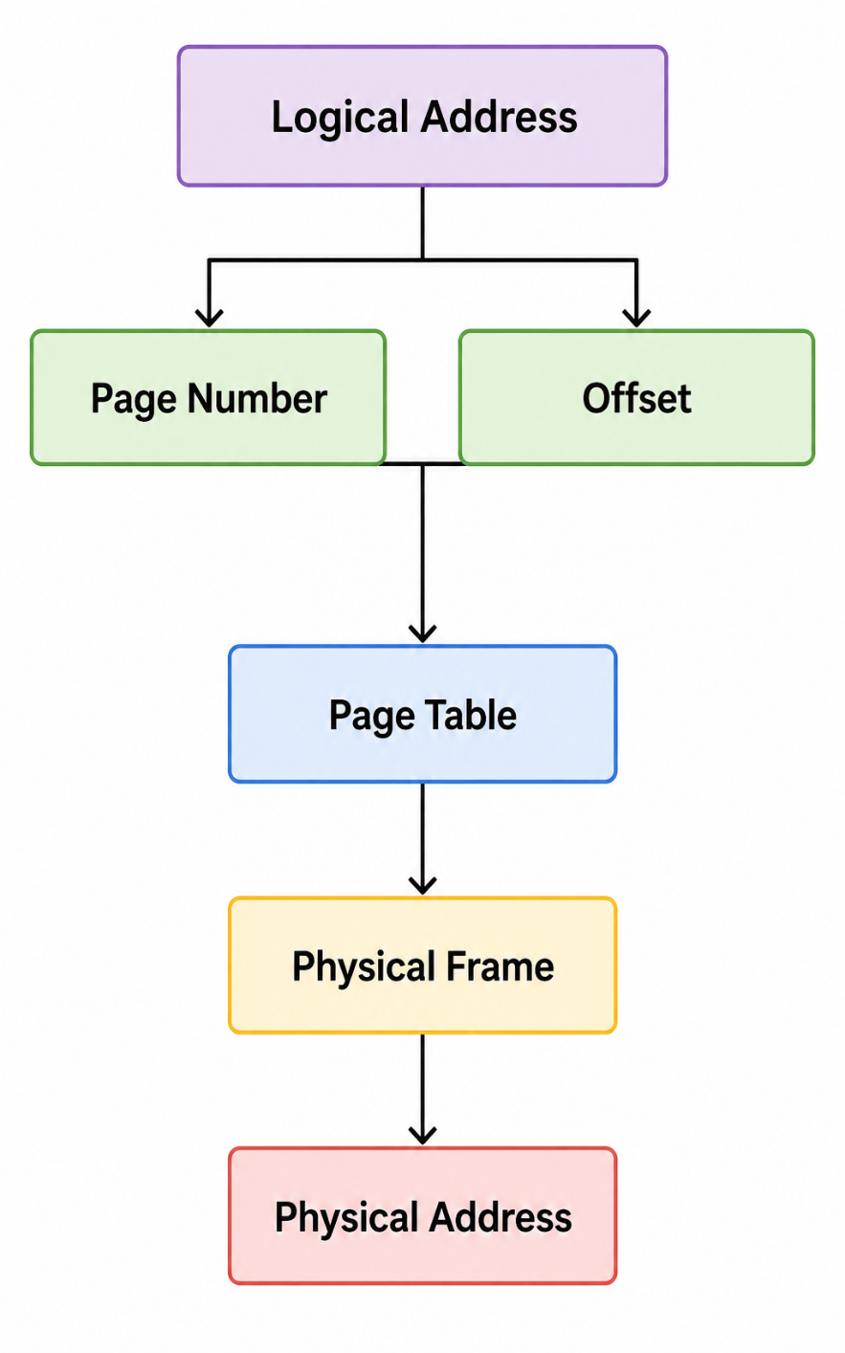

For a 4 KB page size:
Offset = 12 bits
because:
4 KB = 2^12 bytes
For a 64 MB logical address space:
64 MB = 2^26 bytes
Therefore:
Page Number bits = 26 − 12
= 14 bits
Thus the logical address can be represented as:
| Page Number (14 bits) | Offset (12 bits) |
The page table therefore contains 16,384 page-table entries, one for each logical page.

4. Page Replacement Analysis

4.1 Reference String

A representative user-session reference string is selected:
1, 2, 3, 1, 4, 5, 2, 1, 2, 3, 4, 5
Number of frames:
3
The algorithms compared are:
- FIFO
- LRU
- Optimal

4.2 FIFO

FIFO replaces the page that has been in memory for the longest time.
Reference | Frame 1 | Frame 2 | Frame 3 | Fault
1 | 1 | - | - | ✓
2 | 1 | 2 | - | ✓
3 | 1 | 2 | 3 | ✓
1 | 1 | 2 | 3
4 | 2 | 3 | 4 | ✓
5 | 3 | 4 | 5 | ✓
2 | 4 | 5 | 2 | ✓
1 | 5 | 2 | 1 | ✓
2 | 5 | 2 | 1
3 | 2 | 1 | 3 | ✓
4 | 1 | 3 | 4 | ✓
5 | 3 | 4 | 5 | ✓

Total FIFO Page Faults = 10

4.3 LRU

LRU replaces the page that has not been used for the longest period.
Total LRU Page Faults = 10
Although LRU has the same number of faults as FIFO for this particular workload, its replacement decisions are based on recent access behaviour, making it more representative of real-world workloads where temporal locality exists.

4.4 Optimal

Optimal replaces the page whose next use is farthest in the future.
Total Optimal Page Faults = 7
Optimal provides the theoretical minimum number of page faults for the given reference string because it has knowledge of future references.

4.5 Comparison

Algorithm | Frames | Page Faults | Observation
FIFO | 3 | 10 | Simple but may remove frequently reused pages
LRU | 3 | 10 | Uses recent access history
Optimal | 3 | 7 | Lowest possible faults but requires future knowledge

Analysis
For this workload:
Optimal < FIFO = LRU
7 < 10 = 10
Optimal is therefore the theoretical benchmark.
However, it cannot normally be implemented in a real operating system because future page references are unknown.
Between practical approaches, LRU is preferred because it exploits temporal locality and can be approximated using hardware/software mechanisms.

5. Demand Paging and Working-Set Model

When 300 concurrent sessions are active, assigning every process all required pages simultaneously would place significant pressure on physical memory.

Demand Paging

With demand paging, a page is loaded into memory only when it is actually required.
Advantages:
- Reduces unnecessary memory usage.
- Allows more processes to remain active.
- Improves multiprogramming.
- Uses physical memory according to actual demand.
However, excessive page faults can cause thrashing.

Working-Set Model

The working-set model identifies the group of pages that a process is actively using within a recent time window.

For example, assume:

Initial working-set allocation = 32–64 pages/session
A practical dynamic policy can be
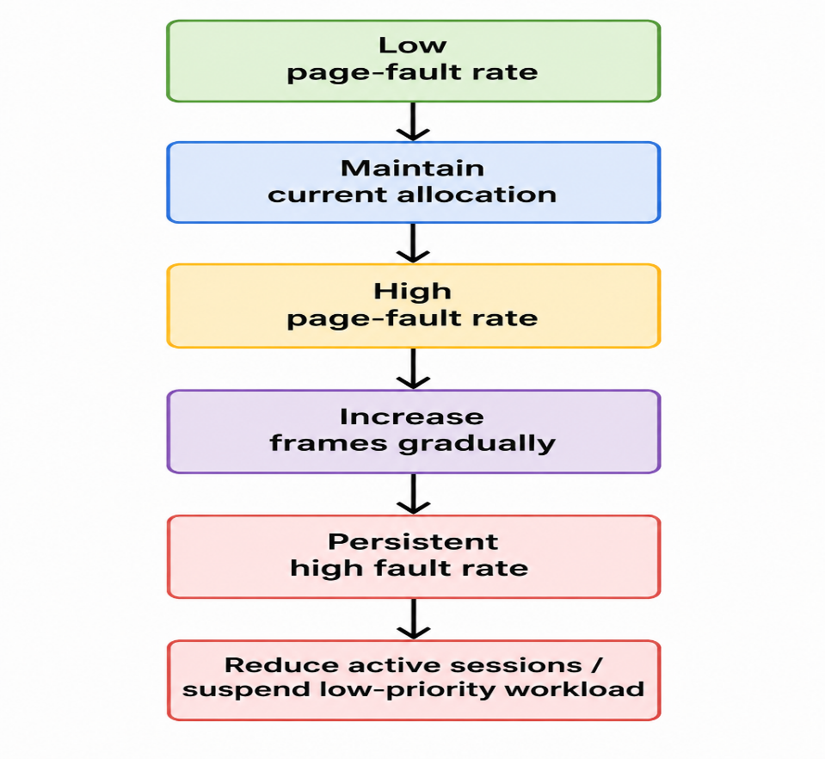

Recommended Policy
For the 300-session scenario, a dynamic working-set policy is recommended instead of giving every process a fixed large allocation.
A starting allocation of approximately 64 pages per active session can be used for simulation, with the allocation adjusted according to observed page-fault frequency.
The policy should maintain:

- Enough frames to hold the active working set, but not so many that a few sessions consume memory unnecessarily.
- This provides a balance between responsiveness, memory utilization, and protection against thrashing.

6. File-System Allocation Methods

Campus Connect handles a mixed workload ranging from small text documents to multi-GB educational videos.

6.1 Comparison

Feature | Contiguous | Linked | Indexed
Sequential Access | Excellent | Good | Good
Random Access | Excellent | Poor | Good
Fragmentation | External fragmentation possible | Low external fragmentation | Low
File Growth | Difficult | Easy | Easy
Large Files | Less flexible | Suitable | Highly suitable
Metadata Overhead | Low | Pointer overhead | Index overhead
Flexibility | Low | High | High

Contiguous Allocation
Stores a file in consecutive disk blocks.

Advantages:
- Very fast sequential access.
- Excellent random access.
- Low metadata overhead.

Disadvantages:
- External fragmentation.
- File growth can be difficult.
- Large files require large contiguous regions.

Linked Allocation
Each block contains a pointer to the next block.

Advantages:
- Files can grow easily.
- External fragmentation is reduced.

Disadvantages:
- Random access is slow.
- Pointer overhead exists.
- A damaged pointer can affect the file chain.

Indexed Allocation
An index block stores pointers to the data blocks belonging to the file.

Advantages:
- Supports direct/random access.
- Flexible file growth.
- Suitable for large files.
- Avoids the requirement for contiguous disk space.

Disadvantages:
- Index blocks consume additional storage.
- Multi-level indexing may be required for very large files.

6.2 Recommendation
- For the Campus Connect mixed workload, Indexed Allocation is the most suitable conceptual choice.
- It provides flexibility for files ranging from small academic documents to very large video files while supporting direct access.
Therefore:
Recommended File Allocation = Indexed Allocation

7. Disk Scheduling Analysis
Given:
Disk Cylinders = 0–199
Initial Head Position = 50
Request Queue =82, 170, 43, 140, 24, 16, 190, 65

Initial direction:
Towards higher-numbered cylinders

7.1 FCFS
FCFS services requests in their arrival order.
Seek Sequence
50 → 82 → 170 → 43 → 140 → 24 → 16 → 190 → 65
Total movement:
|82−50| = 32
|170−82| = 88
|43−170| = 127
|140−43| = 97
|24−140| = 116
|16−24| = 8
|190−16| = 174
|65−190| = 125

Therefore:
Total Head Movement
= 32 + 88 + 127 + 97 + 116 + 8 + 174 + 125
= 767 cylinders
FCFS Result
Total Head Movement = 767 cylinders

7.2 SCAN
SCAN moves the disk head in one direction, services requests along the way, reaches the end, and then reverses direction.
The head initially moves upward.

Seek Sequence
50 → 65 → 82 → 140 → 170 → 190 → 199
→ 43 → 24 → 16
Total movement:
50 → 199 = 149
199 → 16 = 183
Therefore:
Total Head Movement = 149 + 18 = 332 cylinders

SCAN Result
Total Head Movement = 332 cylinders

7.3 C-SCAN
C-SCAN moves in one direction only. After reaching the end, it returns to the beginning without servicing requests during the return.

Seek Sequence
50 → 65 → 82 → 140 → 170 → 190 → 199
→ 0 → 16 → 24 → 43
Total movement:
50 → 199 = 149
199 → 0 = 199
0 → 43 = 43
Therefore:
Total Head Movement
= 149 + 199 + 43
= 391 cylinders

C-SCAN Result
Total Head Movement = 391 cylinders

7.4 Disk Scheduling Comparison

Algorithm | Total Head Movement | Main Characteristic
FCFS | 767 cylinders | Simple and arrival-order based
SCAN | 332 cylinders | Efficient and comparatively fair
C-SCAN | 391 cylinders | More uniform waiting time

Conclusion
For the given workload:
SCAN < C-SCAN < FCFS
332 391 767
SCAN produces the lowest head movement in this test case.
Therefore, SCAN is selected as the primary disk-scheduling strategy because it provides a strong balance between efficiency and fairness.
C-SCAN remains a useful alternative when more uniform waiting time across requests is important.

8. Relation to Unix File-System Concepts
The proposed design can be related to Unix/Linux file-system concepts such as inodes and buffer cache.
Inodes
An inode stores metadata associated with a file, such as:
- File type
- File permissions
- File size
- Ownership
- Timestamps
- References to data blocks
For large academic files, inode-based block addressing can provide flexible access to file contents.

Buffer Cache

Frequently accessed disk blocks can be temporarily maintained in memory through caching.
For example:
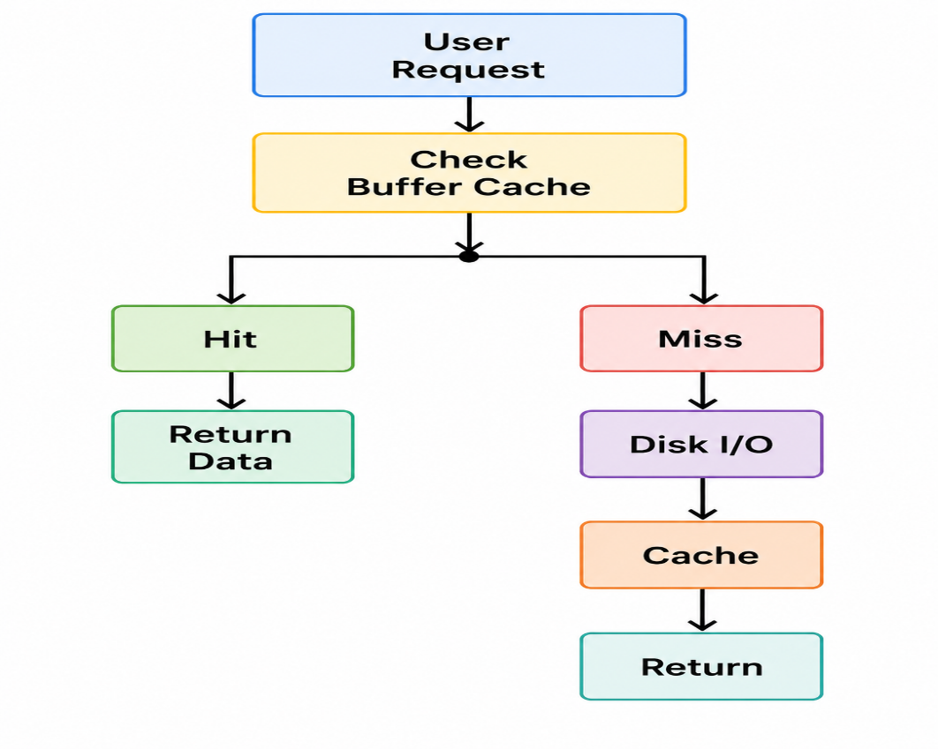
This reduces repeated disk operations and improves response time.

Integrated Approach
The conceptual Campus Connect storage subsystem therefore combines:
Indexed/Inode-based file organization + Buffer Caching + SCAN Disk Scheduling
This creates a balanced storage architecture for mixed academic workloads.

9. Consolidated Solution / Design / Methodology
The complete Campus Connect OS resource-management design integrates synchronization, memory management, and file-system management into one workflow.

9.1 Integrated Architecture
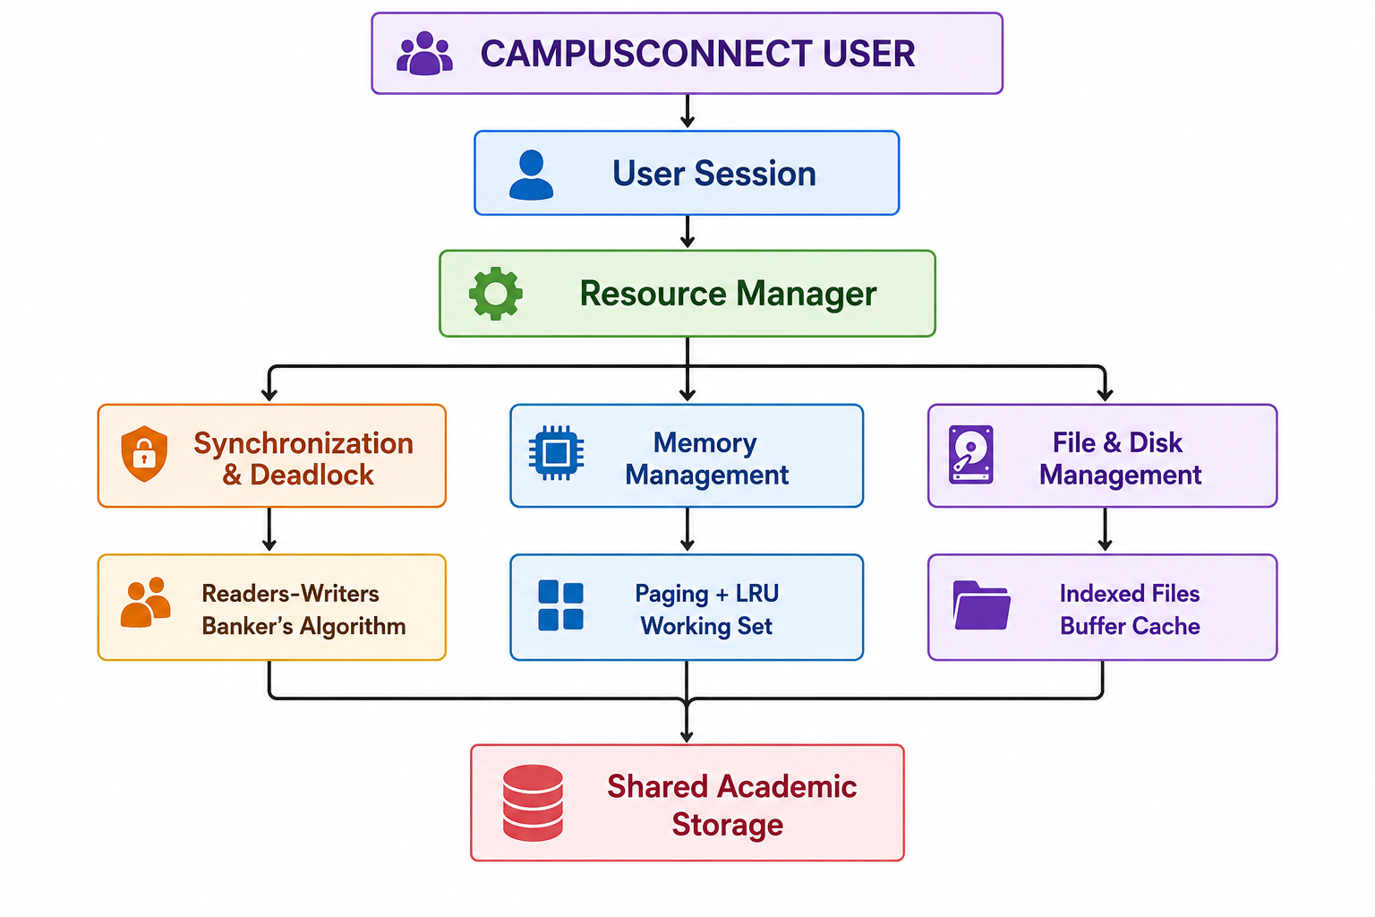
9.2 Complete Access Flow

When a user accesses a shared file:
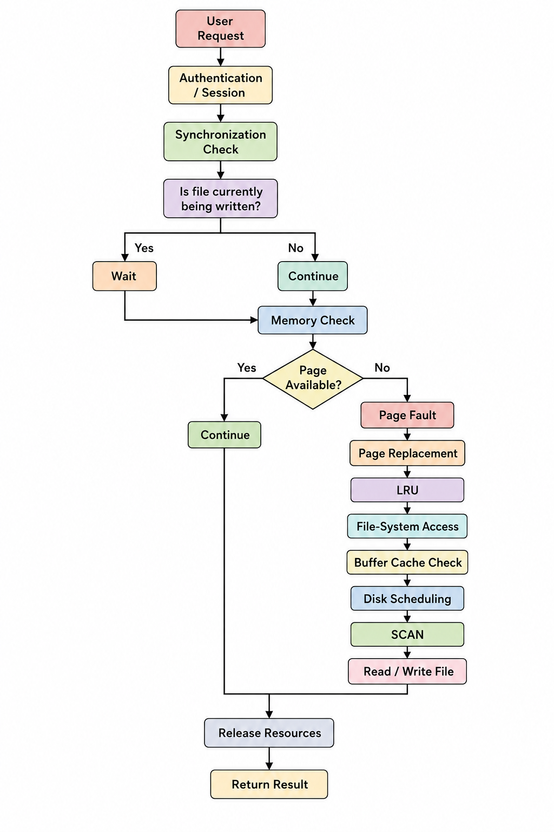
This integrated approach demonstrates how individual Operating Systems concepts cooperate rather than functioning as isolated algorithms.

10. Use of Modern Tools
The proposed design can be implemented and validated using the following tools:

Python
Python can be used to implement:
- Banker's Algorithm
- FIFO page replacement
- LRU page replacement
- Optimal page replacement
- FCFS disk scheduling
- SCAN disk scheduling
- C-SCAN disk scheduling
The program can accept user-defined input and automatically calculate the required metrics.

Linux / WSL

A Linux environment or WSL can be used to demonstrate:

- POSIX threads
- Semaphores
- Concurrent readers and writers
- Synchronization behavior

Streamlit
A Streamlit interface can convert the algorithms into an interactive educational application.
Suggested interface:
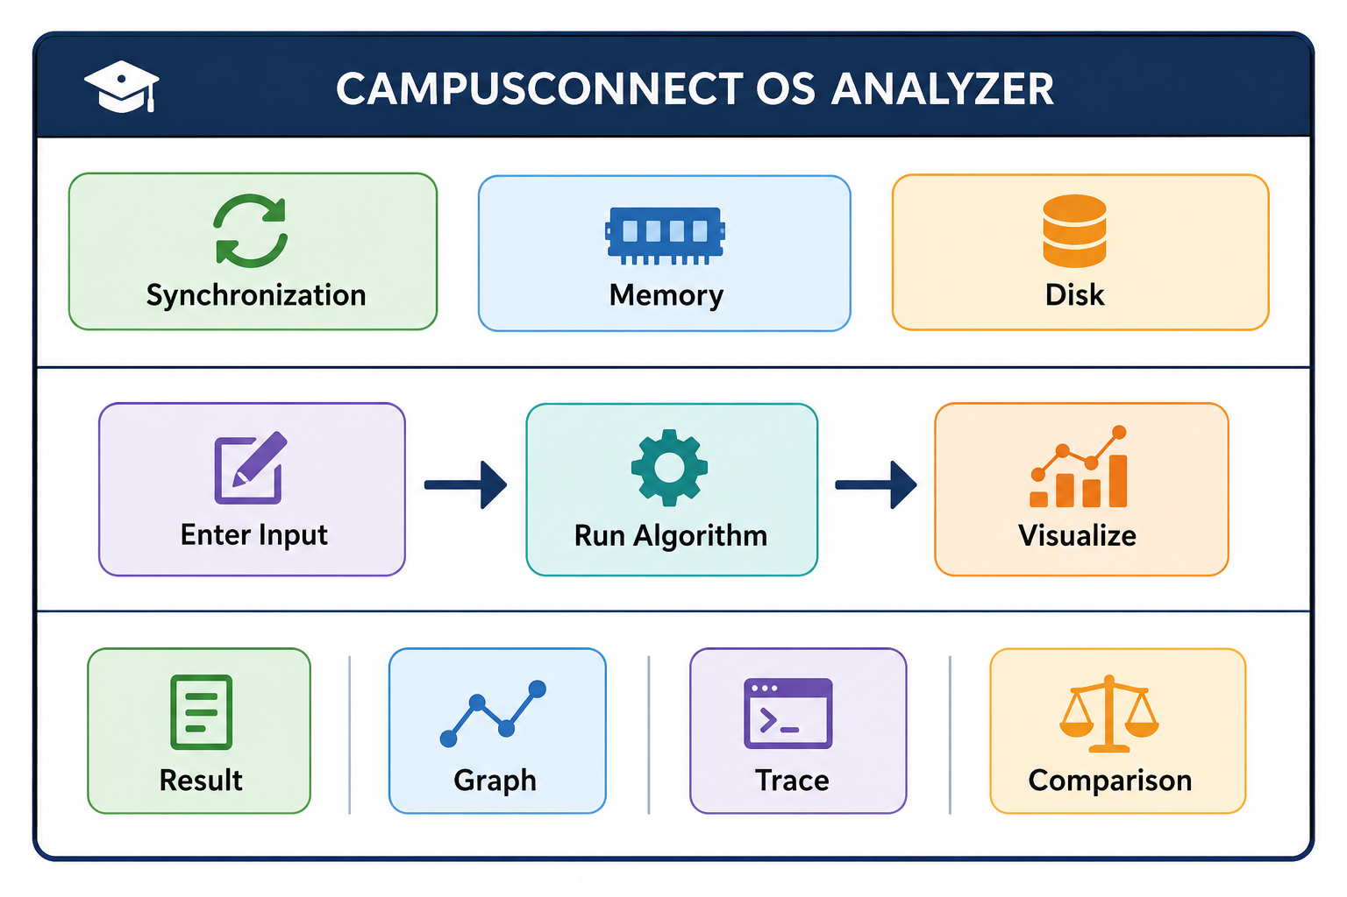
This approach makes the algorithms easier to understand because students can observe the intermediate state rather than seeing only the final answer.

11. Results and Validation

11.1 Page Replacement

Algorithm | Page Faults
FIFO | 10
LRU | 10
Optimal | 7
Optimal provides the lowest theoretical page-fault count.

11.2 Disk Scheduling

Algorithm | Head Movement
FCFS | 767
SCAN | 332
C-SCAN | 391

SCAN produces the lowest movement for the selected workload.

11.3 Banker's Algorithm

Initial State → Safe
Safe Sequence → P1 → P2 → P3 → P4
Therefore, the constructed allocation is safe.

11.4 Synchronization Validation

The Readers-Writers solution ensures:

- Multiple readers can access simultaneously.
- Writers obtain exclusive access.
- Reader/writer race conditions are prevented.
- Shared data integrity is maintained.

12. Analysis and Engineering Decisions

12.1 Page Replacement Decision

Although Optimal produces only 7 page faults, it requires knowledge of future references and therefore cannot normally be used directly in a real operating system.
FIFO produces 10 faults and is easy to implement but may remove a page that is still frequently needed.
LRU also produces 10 faults for the selected test case but makes decisions using recent access behaviour.

Therefore:
Recommended Practical Policy: LRU
Optimal is retained as the benchmark against which practical algorithms can be evaluated.

12.2 Disk Scheduling Decision

The comparison shows:
FCFS = 767 cylinders
SCAN = 332 cylinders
C-SCAN = 391 cylinders
FCFS is simple but causes significantly higher head movement.
SCAN reduces movement while maintaining reasonable fairness.

Therefore:

Recommended Disk Algorithm: SCAN
C-SCAN may be selected for workloads where more uniform waiting time is prioritized over minimum head movement.

12.3 Deadlock Strategy Decision

Strategy | Advantage | Limitation
Prevention | Guarantees avoidance of certain deadlock conditions | Can reduce resource utilization
Avoidance | Allocates resources only when state remains safe | Requires additional computation
Detection & Recovery | Flexible resource allocation | Recovery occurs after deadlock

For Campus Connect:

Deadlock Avoidance is preferred.
The additional safety-check overhead is justified because shared academic resources should prioritize reliability and predictable operation.

13. Broader Considerations

13.1 Reliability and Safety

Data integrity is protected through:
- Mutual exclusion during writes.
- Controlled shared-file access.
- Safe resource allocation.
- Transparent intermediate states.
- Validation of algorithm results.
- Controlled disk access.

The synchronization mechanism prevents simultaneous conflicting modifications to shared academic files.

13.2 Sustainability and Economics

Efficient memory and disk management can reduce unnecessary resource consumption.

For example:
- Demand paging reduces unnecessary memory loading.
- LRU can reduce repeated page faults.
- Buffer caching reduces repeated disk operations.
- SCAN reduces unnecessary disk-head movement.

Lower unnecessary resource usage can contribute to:

Lower hardware utilization → Lower energy consumption → Reduced operating cost

13.3 Accessibility and Society

- A university system may have hundreds of simultaneous users.
- Fair scheduling and controlled resource allocation help prevent a single user or process from monopolizing resources.

The design therefore emphasizes:

Fairness + Responsiveness + Availability

This is particularly important during high-demand periods such as examinations, assignment submissions, and online classes.

13.4 Ethics and Professional Responsibility

Academic systems handle potentially sensitive student and institutional information.

Therefore, the design should follow principles such as:
- Least-privilege access.
- Proper file permissions.
- Protection of student information.
- No unauthorized modification of academic files.
- Transparent algorithmic behaviour.
- Reproducible results.
- Responsible handling of user-generated data.

14. Conclusion

- The proposed Campus Connect resource-management design integrates process synchronization, deadlock avoidance, paging, page replacement, file allocation, and disk scheduling into a unified Operating Systems solution.
- The Readers-Writers synchronization model provides controlled concurrent access to shared academic files, while Banker's Algorithm verifies whether resource allocation remains in a safe state.
- For memory management, the analysis calculated 2,097,152 physical frames for an 8 GB memory with 4 KB pages and 16,384 logical pages for a 64 MB process. Among the evaluated page-replacement algorithms, Optimal produced the lowest page-fault count, while LRU was selected as the practical policy because it uses recent access behaviour.

For storage, Indexed Allocation was selected because of its flexibility for mixed file sizes. For disk scheduling, SCAN achieved 332 cylinders of head movement compared with 767 cylinders for FCFS and 391 cylinders for C-SCAN in the selected workload.

Hence, the final recommended design is:

Readers-Writers + Banker's Algorithm + Demand Paging + LRU + Indexed Allocation + Buffer Cache + SCAN

This integrated design satisfies the major requirements of safety, efficiency, fairness, transparency, and reproducibility. However, the current analysis is simulation-based. Future work could evaluate the design using real university workloads, larger concurrent-session datasets, adaptive memory allocation, distributed storage, and real-time performance monitoring.

15. Student Reflection

What did I learn?

- This assignment helped me understand that Operating Systems concepts are not isolated topics. Process synchronization, memory management, and file-system management are closely connected in a real computing environment.
- For example, when a user accesses a shared file, synchronization determines who can access it, memory management determines which required pages remain in memory, and disk scheduling determines how efficiently the physical storage request is serviced.
- The most important learning outcome was understanding the trade-off between theoretical optimality and practical implementation. For example, Optimal page replacement provides the best theoretical result but cannot normally know future references, whereas LRU provides a practical approximation by exploiting locality.
Similarly, FCFS is simple, but SCAN provides substantially better disk-head movement for the selected workload.
Overall, the assignment improved my ability to move from OS theory → mathematical analysis → algorithm implementation → engineering decision.

What would I improve with additional time?

With additional time and resources, I would extend the system in the following ways:

- Test the algorithms using real university workload traces.
- Implement an adaptive working-set mechanism.
- Add real-time visualization of page faults and disk-head movement.
- Add workload generation for hundreds or thousands of concurrent users.
- Compare additional algorithms such as Clock, C-LOOK, SRTF, and Multilevel Feedback Queue.
- Integrate a distributed file-system model for large academic videos.
- Add performance dashboards showing CPU, memory, and disk utilization.
- Introduce automated test cases to verify edge conditions.
The ultimate goal would be to transform the simulation into a real-time Operating Systems learning and resource-analysis platform rather than a collection of independent algorithm demonstrations.

16. References

- A. Silberschatz, P. B. Galvin, and G. Gagne, Operating System Concepts, Wiley.
- A. S. Tanenbaum and H. Bos, Modern Operating Systems, Pearson.
- W. Stallings, Operating Systems: Internals and Design Principles, Pearson.
- Python Software Foundation, Python Documentation.
- Streamlit , Streamlit Documentation.
- Linux man-pages, POSIX Threads and Semaphore Documentation.
- Course materials and lecture notes for CSA04 – Operating Systems.
- Any additional simulation or visualization tools used during implementation should be cited according to their official documentation.

F. Common Assessment Rubric
Assessment Criterion | Marks
Problem understanding & formulation | 10
Application of course / domain knowledge (Scheduling, Paging, Disk) | 20
Solution methodology / design / implementation | 20
Use of appropriate modern tools / techniques (Streamlit, Python) | 10
Results, testing & validation | 15
Analysis, trade-offs & justification | 15
Broader considerations / professional responsibility | 5
Technical documentation & reflection | 5
TOTAL | 100

G. CO–PO–Assessment Mapping
Assessment Component | CO | PO(s) | Bloom's Level | Marks
Problem formulation | CO1/CO2 | PO1, PO2 | L3 | 10
Application – Process Scheduling | CO1/CO2 | PO1, PO2, PO3 | L3/L4 | 8
Application – Page Replacement | CO3 | PO1, PO2, PO3 | L3/L4 | 6
Application – Disk Scheduling | CO4 | PO1, PO2, PO3 | L3/L4 | 6
Solution / Design – Integrated OSLearn | CO1–CO4 | PO2, PO3, PO5 | L4/L5/L6 | 20
Modern tool usage (Streamlit / Python) | CO1–CO4 | PO5 | L3 | 10
Validation of results | CO1–CO4 | PO4 | L4/L5 | 15
Analysis & justification / trade-offs | CO1–CO4 | PO2, PO4 | L4/L5 | 15
Broader considerations & documentation / reflection | CO1–CO4 | PO6, PO12 | L3/L4 | 10
Note: PO numbers indicated are illustrative; faculty shall verify against the current CSA04 CO–PO matrix and map only the POs genuinely assessed.

H. Faculty Evaluation & Continuous Improvement

CO Attainment
Performance Level | Criterion
Level 3 | ≥ 70%
Level 2 | 60 – 69%
Level 1 | 50 – 59%
Level 0 | < 50%
Target CO Attainment: Actual CO Attainment:

Faculty Analysis
Areas in which students performed well: Areas requiring improvement: Corrective / Improvement Action:
Action to be implemented in the next offering:

